MOZAMBICAN DELEGATION OF ROADMAP PROJECT VISITED REUNION ISLAND
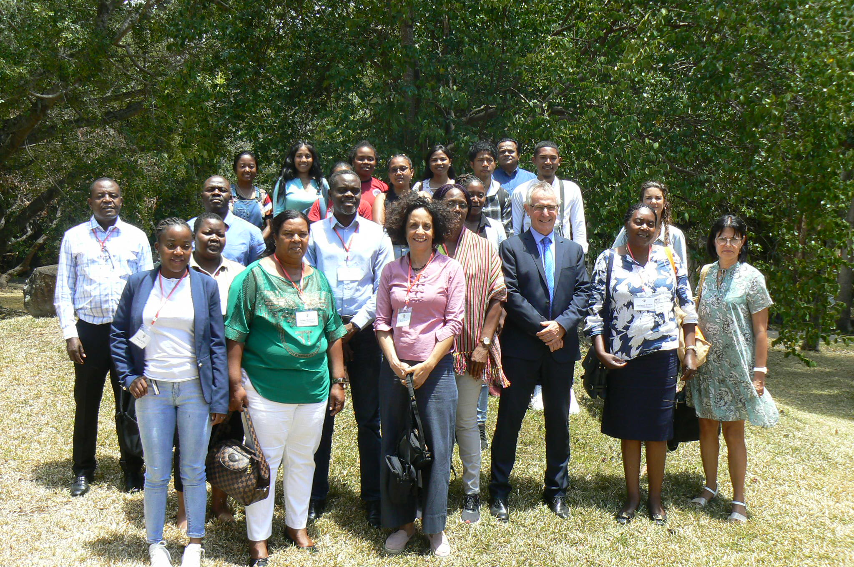

From October 17 to 23, a Mozambican delegation of about ten people was received on Reunion Island (FRANCE). This trip was organized as part of the European Union funded project, H2020 ROADMAP- "Rethinking the use of antimicrobials in livestock production systems".
This project responds to the challenge for global health posed by the proliferation of antimicrobial resistance, partly resulting from an increasing use of antibiotics in livestock, and for which international organizations [WHO, FAO, WOAH (ex OIE ), UNEP)] have made it a priority for action.
In Mozambique, the ROADMAP project supports the implementation of the National Action Plan against Antimicrobial Resistance (NAP AMR) adopted by all the ministries concerned in 2019 (agriculture, health, environment). The project targets an agro-ecological transition in poultry framing, and an integrated approach of health (a "One Health" approach), by improving the control of the circulation of antibiotics for veterinary use, and by supporting the construction of Good Practices Guidelines supporting farming systems less dependent on the use of antibiotics.
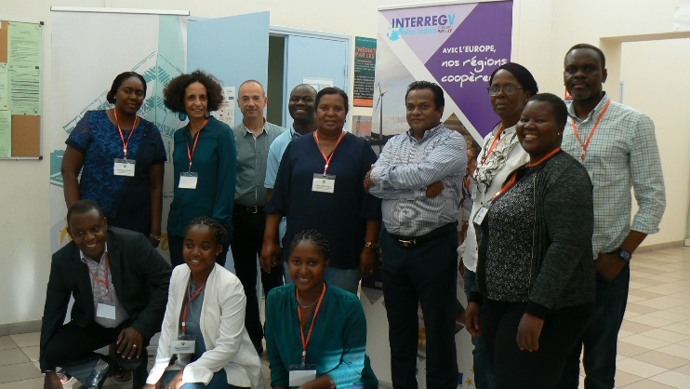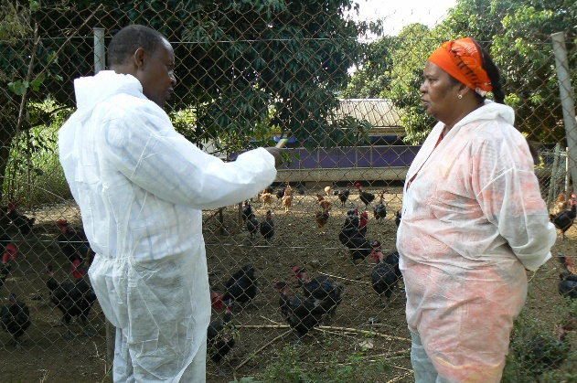
The Mozambican delegation, led by CIRAD (Mr. Figuié, coordinator of the ROADMAP project in Mozambique) was made up of members of the Ministry of Agriculture and Rural Development (MADER), the association of poultry producers in the Province of Maputo (ADAM) and researchers from E. Mondlane University (Faculty of Letters and Social Sciences and Veterinary Faculty).
On Reunion Island, the Direction for Agriculture, Alimentation and Forestry (DAAF, Mr. Daniel Thionohoue) and the Saint-Joseph Agricultural High School (Mr. Vincent Bennet) contributed to the organization of visits and meetings with the local actors of the agricultural sector. The delegation was received by the 1st Vice President of the Region (Mr. Patrick Lebreton) and met several elected officials, in particular Mr. Jean Bernard Maratchia, in charge of agricultural affairs.
The members of the delegation had the opportunity to discuss the structural and organisational challenges posed by an agroecological transition. They met farmers engaged in agro-ecology and organic farming, and visited CIRAD laboratories (in Saint Pierre) working on biological control.
The week ended with a working session at the Regional Council with Mr. Wildfrid Bertile (elected in charge of regional co-development, fisheries and external relations) and Mrs. Thaïs About, in charge for the program's Interreg Indian Ocean. This meeting made it possible to specify the avenues of collaboration to be developed in the field of agricultural training, with a view to regional co-development. This potential collaboration will give continuity to the ROADMAP project who will end in April 2023.

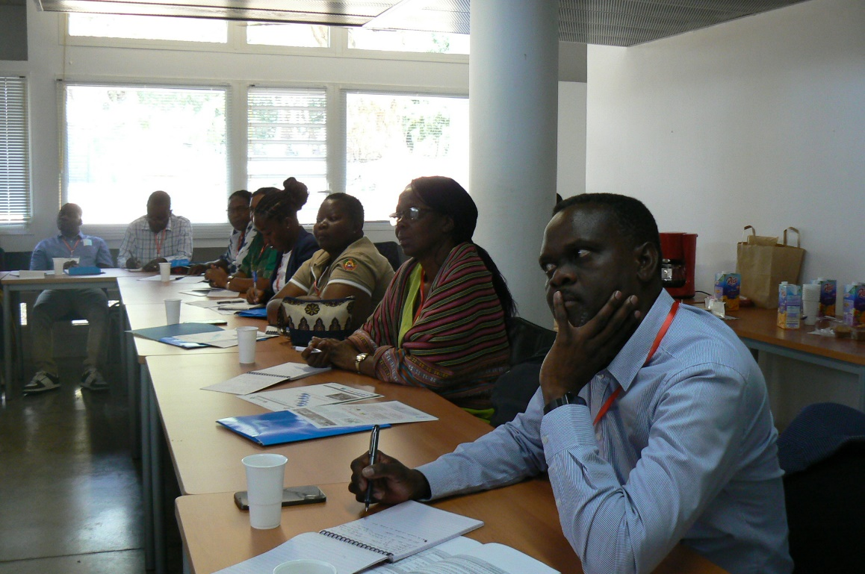
Contacts : Muriel FIGUIE, Sociologist (PhD, HDR), Senior Scientist, Cirad, Montpellier FRANCE
Research Fellow, Universidade E. Mondlane, Maputo , MOZAMBIQUE, muriel.figuie@cirad.fr
Rachid BENLAFQUIH – Africa Project Officer, Office of European Relations and International Collaboration – French Ministry of Agriculture and Food Sovereignty alimentaire, rachid.benlafquih@agriculture.gouv.fr

